**LINUX COMMANDS**

commands – cd, cd --, ls, la -R, ls -a, ls -al, ls -at

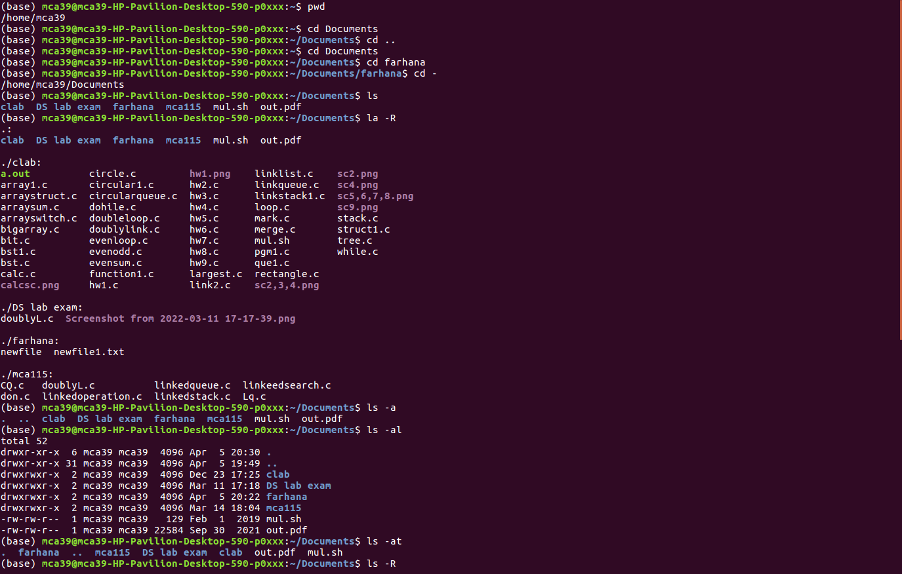

Commands - different cat commands

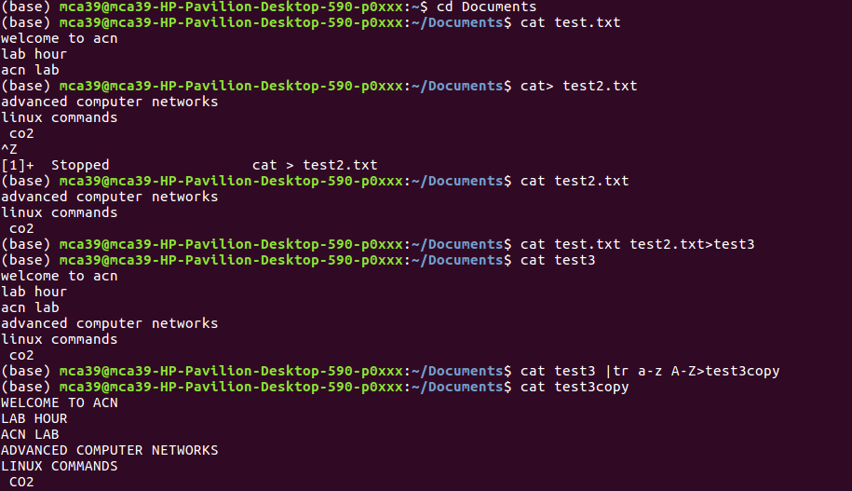

Commands- cp,mv,mkdir,rmdir,rm,touch

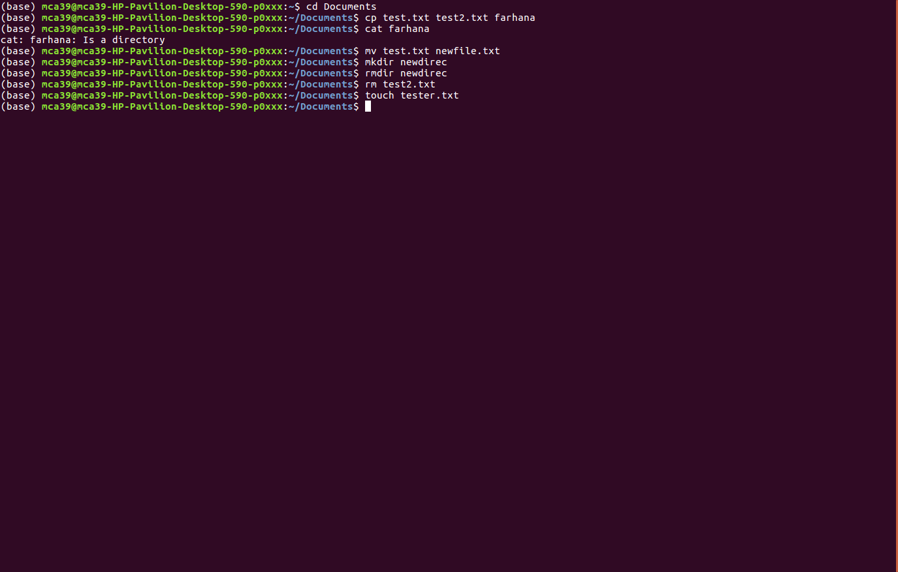

Commands -ps,gedit,grep,ls -l

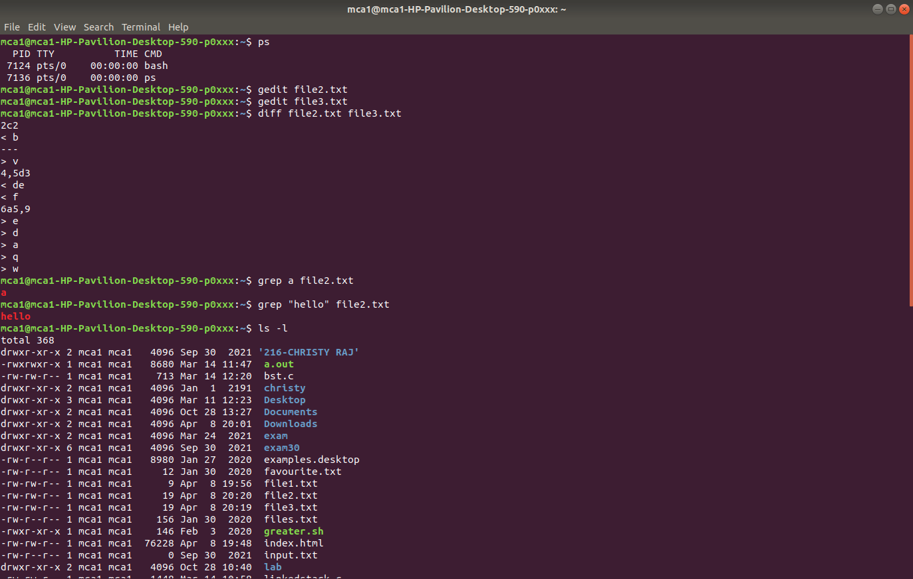

Commands -chmod,head,tail

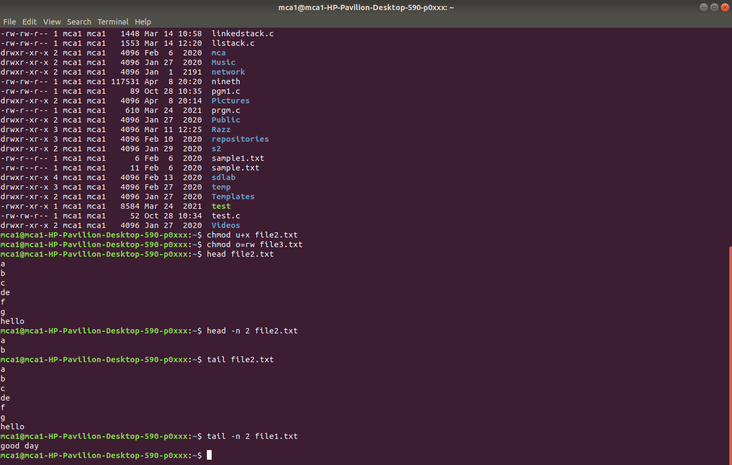

Commands - nano commands,pico commands,emacs

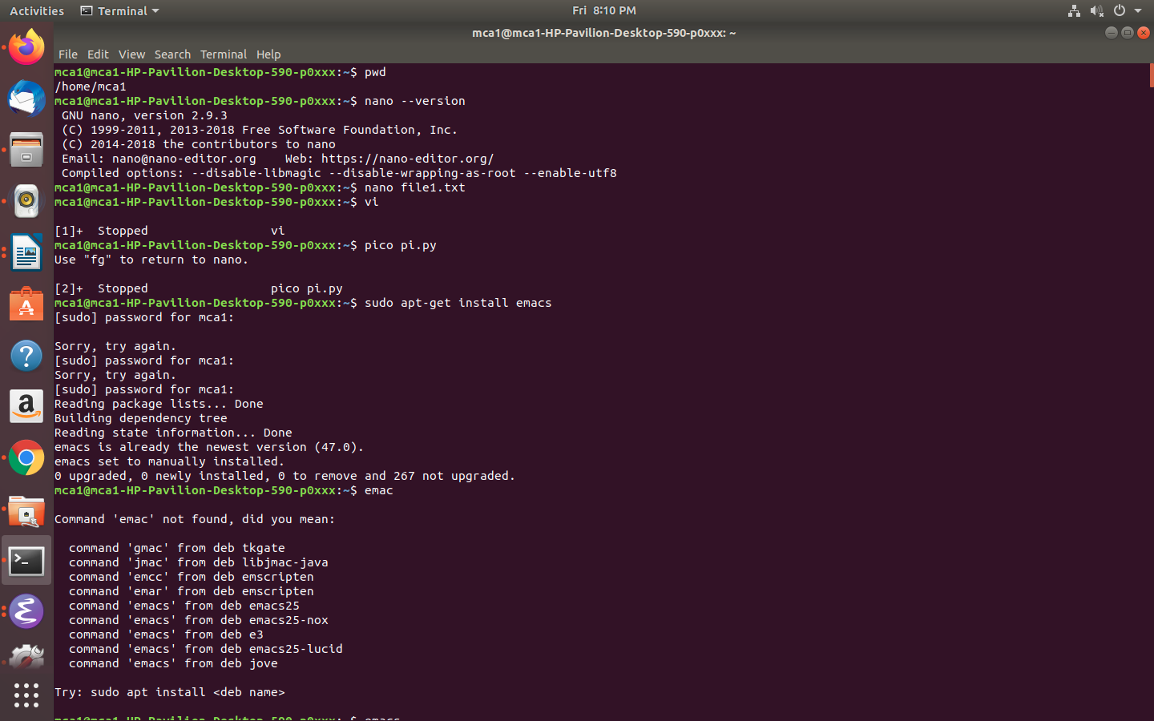

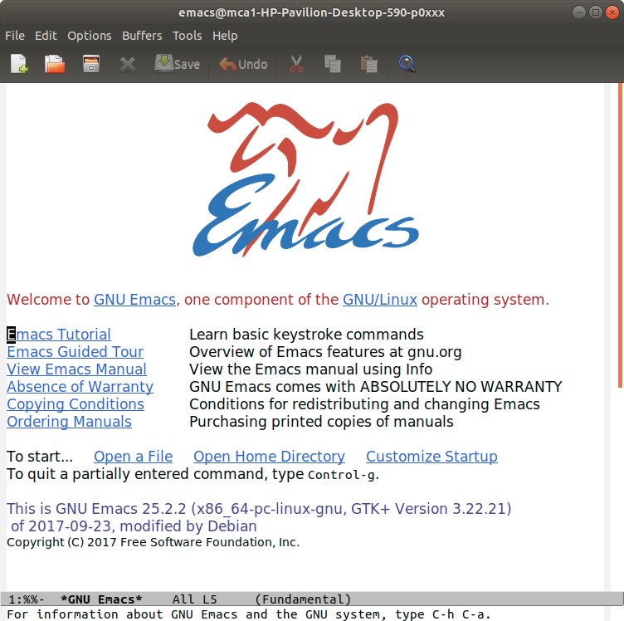

Commands- ping

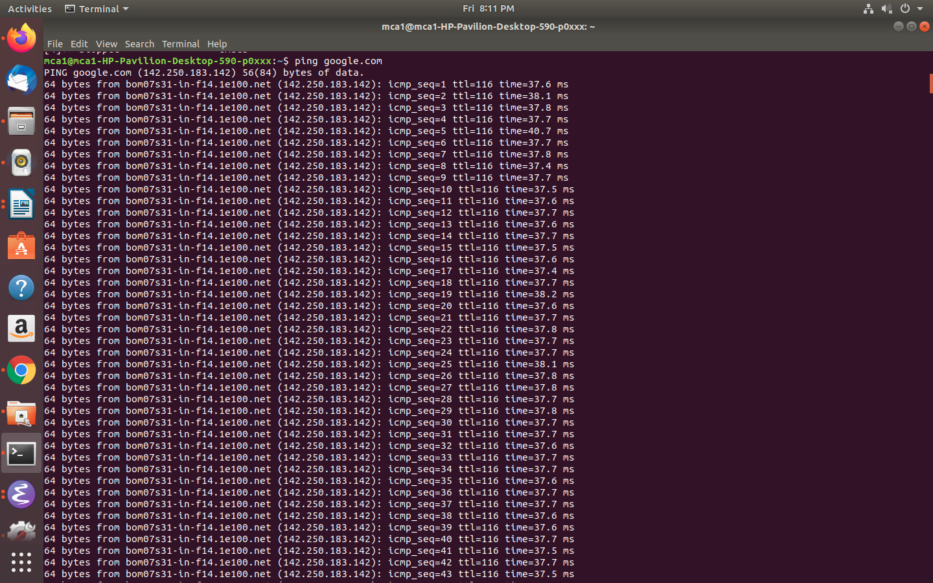

Commands - wget, uname,uname -s, uname -o, uname -a, top

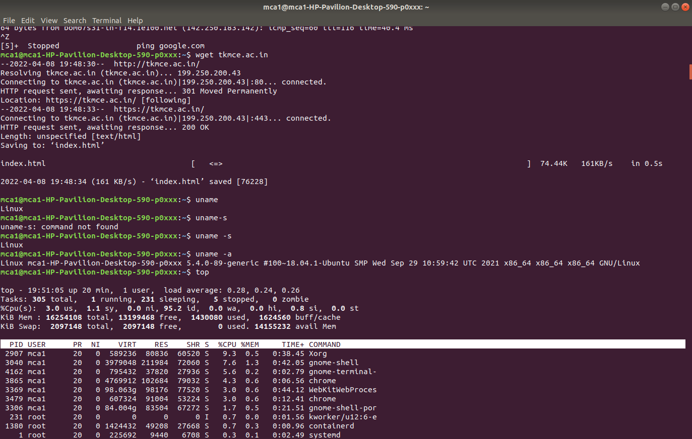

Commands- history

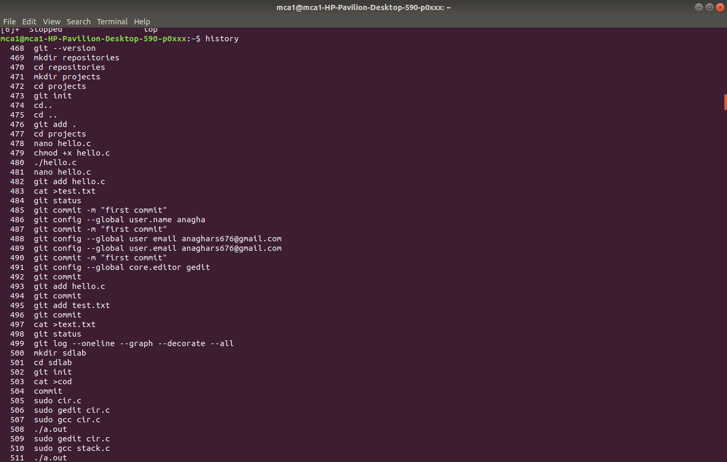

Commands - man ,touch,echo,hostname,useradd,userdel

